**Exercise 1: Implementing the Singleton Pattern**

**Logger.java**

public class Logger {  
 private static Logger *instance*;  
  
 private Logger() {  
 System.*out*.println("Logger instance created.");  
 }  
  
 public static Logger getInstance() {  
 if (*instance* == null) {  
 *instance* = new Logger();  
 }  
 return *instance*;  
 }  
  
 public void log(String message) {  
 System.*out*.println("[LOG]: " + message);  
 }  
}

**LoggerTest.java**

public class LoggerTest {  
 public static void main(String[] args) {  
 Logger logger1 = Logger.*getInstance*();  
 logger1.log("This is the first log.");  
  
 Logger logger2 = Logger.*getInstance*();  
 logger2.log("This is the second log.");  
  
 System.*out*.println(logger1 == logger2 ? "Same instance" : "Different instances");  
 }  
}

**Output:** 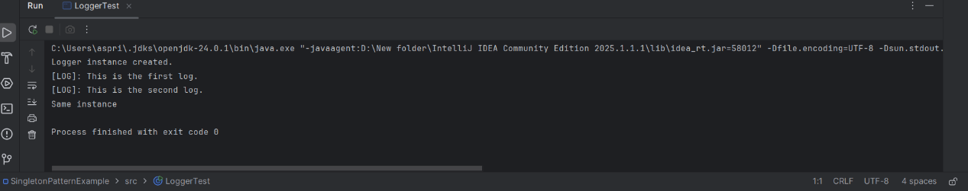

**Exercise 2: Implementing the Factory Method Pattern**

**Document.java**

public interface Document {  
 void open();  
}

**WordDocument.java**

public class WordDocument implements Document {  
 public void open() {  
 System.*out*.println("Opening Word document...");  
 }  
}

**PdfDocument.java**

public class PdfDocument implements Document {  
 public void open() {  
 System.*out*.println("Opening PDF document...");  
 }  
}

**ExcelDocument.java**

public class ExcelDocument implements Document {  
 public void open() {  
 System.*out*.println("Opening Excel document...");  
 }  
}

**DocumentFactory.java**

public abstract class DocumentFactory {  
 public abstract Document createDocument();  
}

**WordDocumentFactory.java**

public class WordDocumentFactory extends DocumentFactory {  
 public Document createDocument() {  
 return new WordDocument();  
 }  
}

**PdfDocumentFactory.java**

public class PdfDocumentFactory extends DocumentFactory {  
 public Document createDocument() {  
 return new PdfDocument();  
 }  
}

**ExcelDocumentFactory.java**

public class ExcelDocumentFactory extends DocumentFactory {  
 public Document createDocument() {  
 return new ExcelDocument();  
 }  
}

**FactoryTest.java**

public class FactoryTest {  
 public static void main(String[] args) {  
 DocumentFactory wordFactory = new WordDocumentFactory();  
 Document word = wordFactory.createDocument();  
 word.open();  
  
 DocumentFactory pdfFactory = new PdfDocumentFactory();  
 Document pdf = pdfFactory.createDocument();  
 pdf.open();  
  
 DocumentFactory excelFactory = new ExcelDocumentFactory();  
 Document excel = excelFactory.createDocument();  
 excel.open();  
 }  
}

**Output:**

